Autonomous Systems Course Project

Report

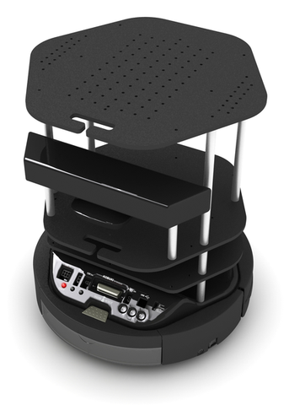

**Project Title** : Autonomous Vehicle (Turtlebot)

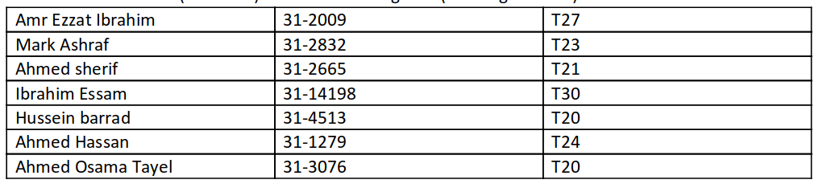

# Introduction

Mobile robots have the capability to move around in their environment and are not fixed to one physical location. By contrast, industrial robots are usually more-or-less stationary, consisting of a jointed arm (multi-linked manipulator) and gripper assembly (or end effector), attached to a fixed surface. a mobile robot would be able to travel throughout the manufacturing plant flexibly applying its talents wherever it is most effective. Autonomously deliver parts between various assembly stations by following special electrical guide-wires using a custom sensor. Other commercial robots operate not where humans cannot go but rather share space with humans in human environments.

For the mobile robot be able to navigate autonomously it should gain information about the environment, Work for an extended period without human intervention, Move either all or part of itself throughout its operating environment without human assistance, Avoid situations that are harmful to people, property, or itself unless those are part of its design specifications.

One important area of robotics research is to enable the robot to cope with its environment whether this be on land, underwater, in the air, underground, or in space.

For a robot to associate behaviors with a place (localization) requires it to know where it is and to be able to navigate point-to-point.

At first, autonomous navigation was based on planar sensors, such as laser range-finders, that can only sense at one level. The most advanced systems now fuse information from various sensors for both localization (position) and navigation. Systems such as Motivity can rely on different sensors in different areas, depending upon which provides the most reliable data at the time, and can re-map a building autonomously.

Outdoor autonomy is most easily achieved in the air, since obstacles are rare. Cruise missiles are rather dangerous highly autonomous robots. Pilotless drone aircraft are increasingly used for reconnaissance. Some of these unmanned aerial vehicles (UAVs) are capable of flying their entire mission without any human interaction at all except possibly for the landing where a person intervenes using radio remote control. Some drones are capable of safe, automatic landings, however. An autonomous ship was announced in 2014—the Autonomous spaceport drone ship—and is scheduled to make its first operational test in December 2014.

The greatest single shortcoming in conventional mobile robotics is, without doubt, per-ception: mobile robots can travel across much of earth’s man-made surfaces, but they cannot perceive the world nearly as well as humans and other animals.

But perception is more than sensing. Perception is also the interpretation of sensed data in meaningful ways.

# Literature Review

In developed engineering and technology, the concept of autonomy of mobile robots encompasses many areas of knowledge, methodologies, and ultimately algorithms designed for trajectory control, obstacle avoidance, localization, map building, and so on. Practically, the success of a path planning and navigation mission of an autonomous mobile robot depends on the availability of an accurate representation of the navigation environment.

Global path planning requires a completely known environment and a static terrain. In this approach, the algorithm develops a complete path from the source point to the target point before the robot starts its motion. Thus previous knowledge of the whole environment is needed. On the other hand, local path planning means the environment is completely unknown to the mobile robot; in other words, the algorithm is capable of developing a new path to reach at the destination point. This requires the mobile robot to perceive its environment as it navigates through it. Different path planning approaches for autonomous mobile robots are reviewed below.

Considering classical methods used for path planning, In the roadmap approach, the mobile robot connects the source point to the target point by curved or straight lines. Once a roadmap is created, it is used as a network of roads (path) for mobile robot motion planning. Path planning is thus reduced to connecting the starting and final positions of the robot to the road network, then finding a series of roads from the starting robot position to its destination. Two famous roadmap approaches are the visibility graph and Voronoi diagram. Bacaa et al. (2011) have proposed an indoor appearance-based mapping and a localization approach for mobile robots based on the human knowledge model, which was used to construct a Feature Stability Histogram (FSH) at each node in the robot topological map. In another study, Amigoni and Caglioti (2010) presented a mapping system utilizing an information-based exploration strategy that allows a mobile robot equipped with a laser range scanner to efficiently build the map of an unknown environment. Remazeilleshas and Chaumette (2007) developed a new control method for robot navigation, in which an image path is first extracted from visual memory describing the environment. Then this image path defines the visual features that the camera should observe during the motion. Kim and Cho (2006) have investigated a new 3D sensor system for environment recognition needed for mobile robots with less scanning time using multi-stripe laser pattern projection, composed of the laser pattern projector of generating multiple line stripes and two cameras with laser band-pass filters.

Another classical method is the cell decomposition method. The basic idea behind cell decomposition is to discriminate between geometric areas or cells that are free and areas that are occupied by obstacles. An important aspect of the cell decomposition method is the placement of boundaries between cells. If boundaries are placed as a function of the structure of the environment, such that the decomposition is loss-less, then the method is termed exact cell decomposition. If decomposition results in an approximation of the actual map, the system is called as approximate cell decomposition method. Shojaeipour et al. (2010) presented a novel method for mobile robot navigation by visual environments. This approach implemented on motion robots verifies the shortest path via the Quad-tree Decomposition method (QD). Rekleitis et al. (2002) presented an algorithm on a team of mobile robots for the complete coverage of free space. They developed a new multi-robot coverage algorithm similar to single robot planar cell-based decomposition. This method permits planning to occur for a team of robots in a 2D configuration field.

On the other hand some heuristic methods exists such as fuzzy logic controller technique. Fuzzy logic provides a formal technique representing and implementing human experts’ heuristic knowledge and perception-base actions, and was developed by Prof. Zadeh in1965. In fuzzy logic controller behavior based navigation, the problem is broken down into simpler tasks (independent behaviors) and each behavior is composed of a set of fuzzy logic rule statements intended at achieving a well-defined set of objectives. Pradhan et al. (2009) have used different fuzzy controllers to control the motion of multiple mobile robots in a highly cluttered environment. They have given right obstacle distance, left obstacle distance; front obstacle distance and heading angle input to the controller, and the output the from controller are left wheel velocity and right wheel velocity of mobile robot.

Another heuristic method is the Neural Network technique. Robot motion in the real-world environment was planned through the dynamic activity landscape of the artificial neural network without explicitly searching free space or collision-free paths, without explicitly optimizing any cost function, without any prior knowledge of the dynamic environment, without any learning process, and without any local collision checking procedures. Developing autonomously an ideal control action arrangement for the Autonomous Guided Vehicle (AGV) system based on Artificial Neural Networks was discussed by Patiln and Carelli (2004). The principal objective in this paper is to autonomously design an optimal controller that can control the center of the vehicle through a number of via nodes in a particular sequence using a minimum amount of time. Engedy and Horvath (2009) described a dynamic artificial neural network based on the mobile robot motion and path planning system. According to them, the motion controlling ANN is trained online with an extended back propagation through time algorithm, which uses potential fields for obstacle avoidance and the paths of moving obstacles predicted by other ANNs for better obstacle avoidance. The Intelligent Neuro-Controller for Navigation of Mobile Robot was presented by Singh and Parhi (2009). They gave right obstacle distance, left obstacle distance, front obstacle distance and target angle input to the neural controller, and the output from the controller was the steering angle of mobile robot. They also used a four layer neural network to design and develop the neuro-controller to solve navigation problems of mobile robots. Xiao et al. (2007) considered a multi-layer feed forward artificial neural network (ANN) to construct a path planning controller by its powerful nonlinear functional approximation.

Further heuristic methods exists such as Neuro- Fuzzy technique (Parhi et al. ,2006), Genetic Algorithm technique (Nagib and Gharieb, 2004), Ant Colony Optimization technique (Chen et al. 2011) and Artificial Immune Network technique (Farmer et al. ,1986).

|  |  |
| --- | --- |
| Components | photo |
| Arduino Mega 2560 Rev3 |  |
| Sharp GP2Y0A710K0F IR Range Sensor |  |
| HC-05 Bluetooth Module |  |
| Standard Servo Motor (3.2 kg.cm) |  |
| MPU 6050 |  |
| TurtleBot 2 (Manufacturing) |  |
| Robot Wheels (Tire) with Coupler |  |
| DC MOTOR with Encoder (3.2 Kg.cm - 250 RPM - 6V) |  |
| L298 Dual H-Bridge Motor Driver |  |
| Metal Caster Wheel |  |
| Lithium Polymer Battery |  |
| Laptop Running MATLAB |  |

Milestones

|  |  |
| --- | --- |
| Milestone #1 | Report And Literature Review |
| Milestone #2 | Manufacturing and components purchase |
| Milestone #3 | Navigation and Localization |
| Milestone #4 | Mapping |

# Milestone 2

In this milestone we have done two things. First the manufacturing of the robots body.

We designed the robot on solidworks and manufactured the design using laser cutter machine in our university.



the body was made from acrylic material. And assembled using screws and nuts.

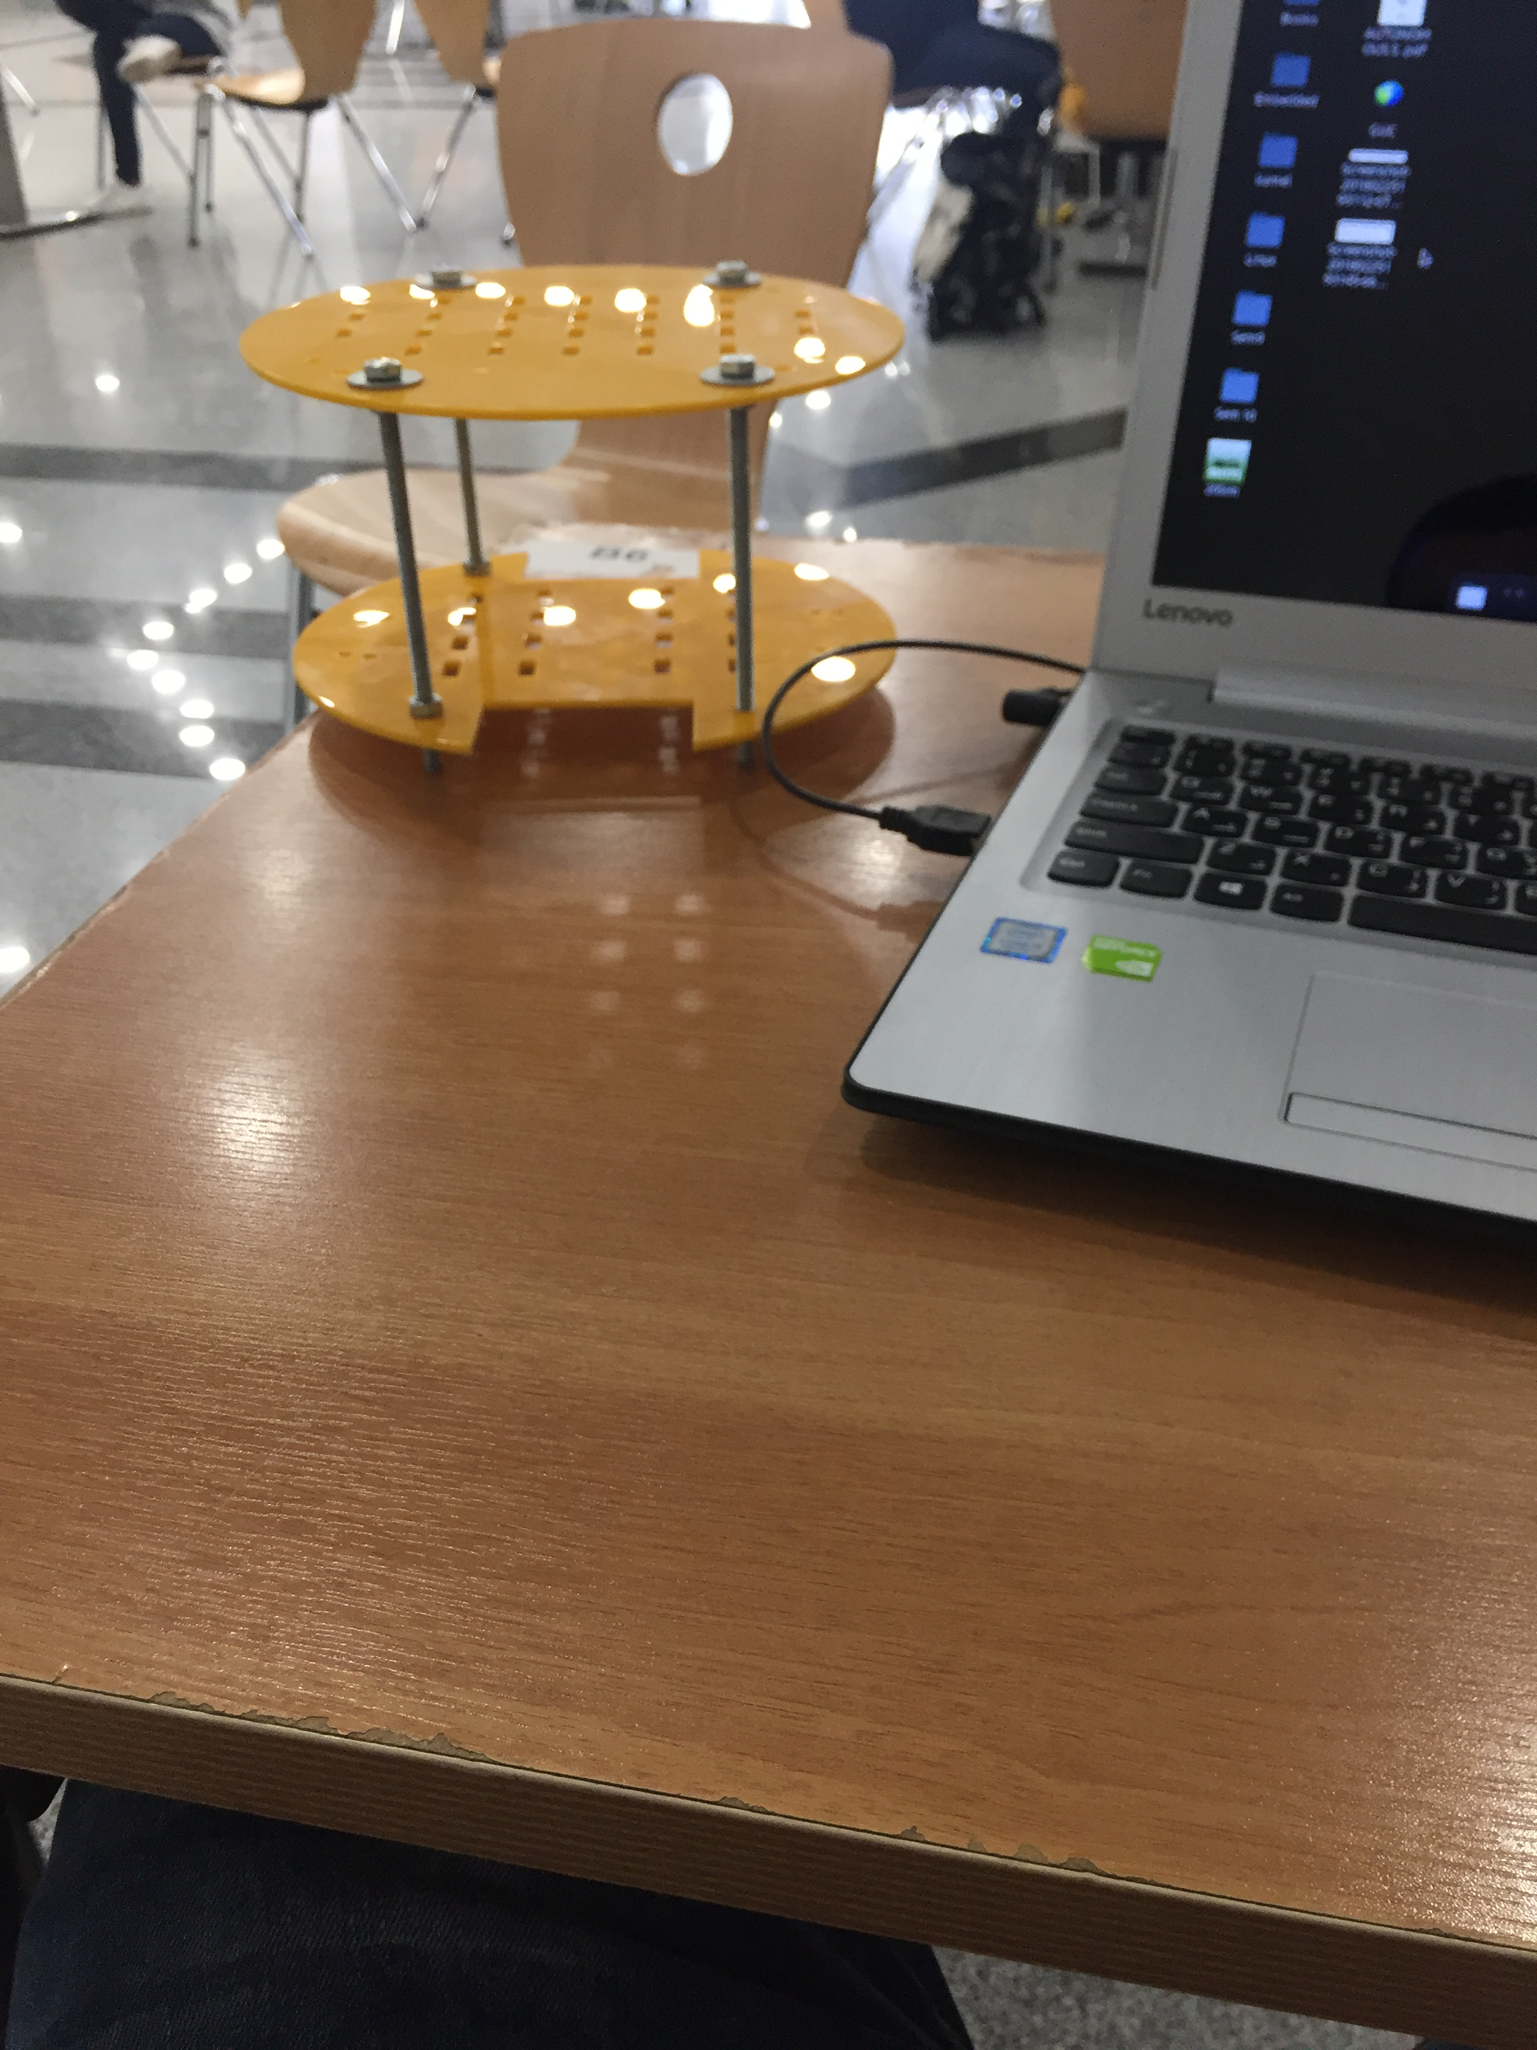

Then we bought all the required components and begin to assembly the components with the body.

Due to the bad quality of components in the market. We faced many issues assembling and running the components.

Also we couldn't find some components so we had to find the alternatives. And it was hard task

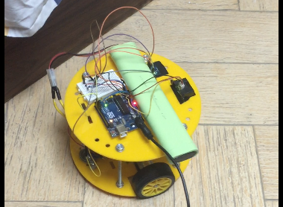

the above photo of the full robot assembled and working on open loop control.We finished all the required codes for sensor interfacing with arduino and tested all the sensors together, also we manged to send the sensors reading to the laptop through serial communication.

We created github repository to store all the project source codes and designs. You can find the repository of the following link

<https://github.com/HemaZ/AMRArduino>

we used Kalman filter for the MPU6050 sensor, and the motors encoders were attached to the interrupt service routine in the Arduino.

We will use two arduino Mcus, one for the IMU sensor and the IR sensors. And the other one for the motor Encoders and speed.